Types of Adverbs
# Source: AI Source: Provided by: [Data Path: Persons Table -> ID Column: 1, Name_En Column: Motasem Essam] -> From: [Chatgpt (GPT-4-turbo)] on [7/27/2025]
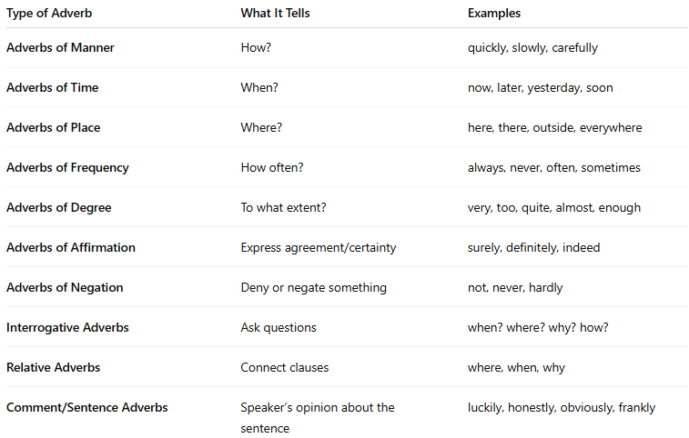

Type of Adverb | What It Tells | Examples
Adverbs of Manner | How? | quickly, slowly, carefully
Adverbs of Time | When? | now, later, yesterday, soon
Adverbs of Place | Where? | here, there, outside, everywhere
Adverbs of Frequency | How often? | always, never, often, sometimes
Adverbs of Degree | To what extent? | very, too, quite, almost, enough
Adverbs of Affirmation | Express agreement/certainty | surely, definitely, indeed
Adverbs of Negation | Deny or negate something | not, never, hardly
Interrogative Adverbs | Ask questions | when? where? why? how?
Relative Adverbs | Connect clauses | where, when, why
Comment/Sentence Adverbs | Speaker’s opinion about the sentence | luckily, honestly, obviously, frankly

